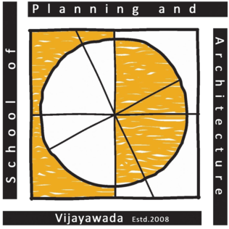 | School of Planning and Architecture: Vijayawada
 | (An institution of National Importance under the Ministry of Education, Govt. of India)
 | Survey No.4/4, ITI Road, Vijayawada-520008, Andhra Pradesh, India
Department of Architecture | Master of Urban Design
Course: | MUD211 - Urban Mobility |  | Class: II Year - III Semester 2026
Instructors: | Ar. Ch Dheeraj Venkata Manikanta |  | Internal Assessment: 50
Instructors: |  |  | External Theory Exam: 50
Contact Periods/ week: 03 periods. (55 min each) |  |  | Total Marks: 100
Time Table: | Monday (03 periods) |  | Credits: 3
Objective: This course aims to expose the student to urban mobility networks and how the movement corridors directly influence the urban design of different cities in India. At the same time a more nuanced understanding of issues related with urban mobility especially related to public transport, pedestrian spaces and emerging trends are to be provided in this course.

Week | Lecture Plan | Remarks/Topic of Assignment
Week 1 | Introduction to Urban Mobility, Importance and Role of Transport in Urban Design | Discussion
Week 2 | Transportation, Connectivity, Mobility, Accessibility  Urban Transport, Types of Urban Mobility Systems | Lecture + Discussion
Week 3 | Transport Modes in Cities - NMV, IPT, Public Transport, Private Transport. Framework for Selection of Public Transport System | Lecture + Discussion
Week 4 | Land Use & Transport,  Sustainable Planning and Design for Mobility  Urban Form and Movement Networks | Lecture + Assignment
Week 5 | Environmental and Social Sustainability in Transport  Sustainable Urban Mobility Plan | Lecture + Discussion
Week 6 | Complete Streets  Street Design Guidelines | Lecture + Assignment
Week 7 | Street Design Guidelines | MID SEM Assessment

Week 8 | Application of Geo-informatics & Space syntax | Lecture
Week 9 | Transport Metrics and Key Performance Indicators | Lecture + Discussion
Week 10 | Case Study based Learning | Lecture + Student Activity
Week 11 | Case Study based Learning | Lecture + Student Activity
Week 12 | Case Study based Learning | Lecture + Student Activity
Week 13 | Design for Transit - TOD, Last mile connectivity, Walkability & Pedestrian environments | Student Activity
Week 14 | Mobility Systems and ITC interfaces  Smart Transportation | Student Activity
Week 15 | Role Play Discussion/Debate | Lecture + Student Activity
Week 16 | Concluding Class | Discussion

S. No. | Stages of Evaluation | Weightage
1 | First stage: Assessment | 15
2 | Mid-Semester Examination | 20
3 | Third stage: Assessment | 15
 | Total | 50
Outcome: A Critical overview of urban mobility and its impact on achieving a liveable city.
Cource Instructors:  sd/-  (Ar. Ch Dheeraj Venkata Manikanta) |  | Head of Department :  sd/-  (Dr. Amitava Sarkar)

